Formulating Crop Patterns Using GIS
Domain:Electronics and Communication

Participant 1 Participant 2

Name: Vishnu Vytla
Roll No: 17071A04I0
College: VNR VJIET
Email Address: vishnu.purpose@gmail.com
Name: Venkat Pathi Naidu
Roll No:17241A0487
College: GRIET
Email Address:
venkatrok@gmail.com

Abstract -Assisting Gram Panchayat in formulating crop patterns,and preparing crop calenders from Remote Sensing data of groundwater and irrigation resources using Predictive Modeling. Using Backward Step-Wise Regression algorithms to process Remote sensing data obtained from satellite images, to predict the availability of water resources. The objective is to shift focus from land productivity to water productivity to maximize agricultural output.

Keywords—remote sensing, geographical information systems(GIS),IRNSS,CARTOSAT,AVHRR,regression,predictive modelling.

Introduction
Problem Statement
Crop failure and low agricultural output due to
- Falling ground water levels
- Mismanagement of Surface Irrigation resources
- Erratic monsoon rainfall
- Highly water intensive crop patterns
WHY IT THIS IMPORTANT?
“appropriate mechanism needs to be framed for economical use of water among small and marginal farmers.”
“The States like Tamil Nadu, Karnataka, Maharashtra and Andhra Pradesh which have high land productivity tend to have very low irrigation water productivity, reflecting inefficient use of water and the need to re-calibrate the cropping pattern.”
“focus in agriculture should shift from ‘land productivity’ to ‘irrigation water productivity.’”
“The cropping pattern in India is highly skewed towards crops that are water intensive.”

-Economic Survey 2018-2019
MINISTRY OF FINANCE,GOVERNMENT OF INDIA.

“Groundwater was the only source of irrigation among victim households of Uttar Pradesh and Haryana. Majority of the area of victim households of Punjab (68%) and Tamil Nadu (64%) were dependent on surface water.”
”The victim households mentioned that the recharge capacity of tube well was too low and the surface water source goes dry in the mid of the crop season, resulting in crop failure as they could not get water at crucial stages of the crop growth.”

“Failure of crops in successive years as a probable cause of farmer suicide accounts to 60% of total deaths.”

-Farmer Suicides,ALL INDIA STUDY July 2017
Department of Agriculture, Cooperation & Farmers Welfare, Government of India, New Delhi

Proposed Solution
Assisting gram panchayat in formulating crop patterns based on expected water availability.
Remote sensing is the acquisition of information about an object or phenomenon without making physical contact with the object and thus in contrast to on-site observation, especially the Earth.
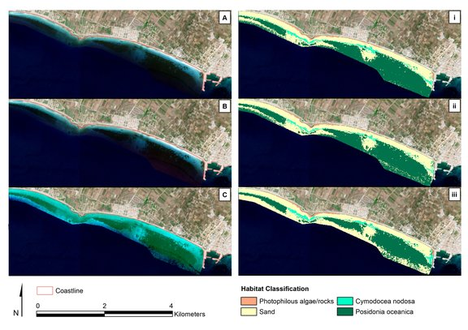
A geographic information system (GIS) is a system designed to capture, store, manipulate, analyze, manage, and present spatial or geographic data. GIS applications are tools that allow users to create interactive queries (user-created searches), analyze spatial information, edit data in maps, and present the results of all these operations.
The hydrologic studies at regional scales requires heterogeneous data that are often expensive to acquire on the ground. As a result, satellite-based remote sensing has become a powerful tool for surface hydrology .
Remotely sensed indicators of ground water may provide important data where practical alternatives are not available.
Technology involved:
1.Remote sensing and geographical information systems (GIS).
- Predictive modeling algorithms.
METHODOLOGY:
The principle of extracting surface water from optical images is the obviously lower reflectance of water, compared to that of other land cover types, in infrared channels.
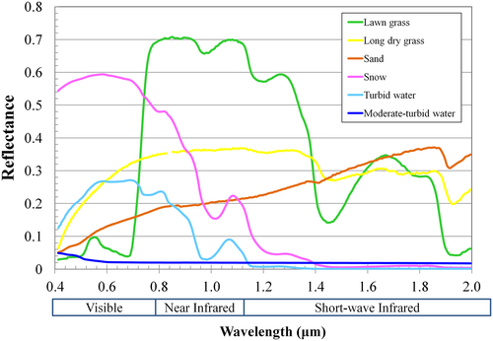
An easy and effective way to extract water is to use water indices, which are calculated from two or more bands, to identify the differences between water and non water areas. Many indices have been developed to extract surface water areas or flood inundation extent.
Some of the factors to be considered in temporal data analysis.

INPUTS FROM SATELLITE DATA:

1.Ground Water levels.
2.Water present in catchment area/tank/reservoir.
3.Distance from nearest canal/tank/reservoir.
4.Water levels in rivers and canals upstream.
5.Average Water consumption for existing crop patterns.

INPUTS FROM LOCAL GOVERNING BODIES:

1.Average Borewell Depth.
2.Rate of water inflow/outflow from Dams/tanks.
3.Survey data of Irrigation projects to be considered.
4.Existing and previous crop patterns and its performance.
5.Annual and seasonal agricultural output.
6.Weather and rainfall data.
GIS PLATFORM
A remote sensing software is a software application that processes remote sensing data. Remote sensing applications are similar to graphics software, but they enable generating geographic information from satellite and airborne sensor data. Remote sensing applications read specialized file formats that contain sensor image data, georeferencing information, and sensor metadata.
STEP-WISE REGRESSION
Stepwise regression is a combination of the forward and backward selection techniques. It was very popular at one time, but the Multivariate Variable Selection procedure described in a later chapter will always do at least as well and usually better.
Stepwise regression is a modification of the forward selection so that after each step in which a variable was added, all candidate variables in the model are checked to see if their significance has been reduced below the specified tolerance level. If a non-significant variable is found, it is removed from the model. Stepwise regression requires two significance levels: one for adding variables and one for removing variables. The cutoff probability for adding variables should be less than the cutoff probability for removing variables so that the procedure does not get into an infinite loop.
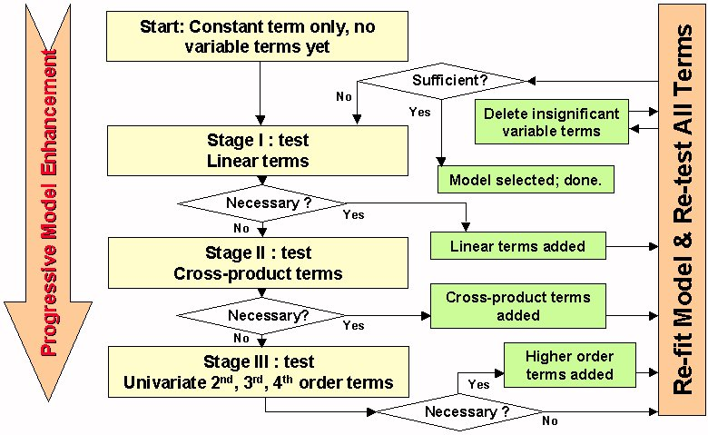
Backward (Step-Down) Selection
This method is less popular because it begins with a model in which all candidate variables have been included. However, because it works its way down instead of up, you are always retaining a large value of R-Squared. The problem is that the models selected by this procedure may include variables that are not really necessary. The user sets the significance level at which variables can enter the model.
The backward selection model starts with all candidate variables in the model. At each step, the variable that is the least significant is removed. This process continues until no non-significant variables remain. The user sets the significance level at which variables can be removed from the model.
This procedure performs one portion of a regression analysis: it obtains a set of independent variables from a pool of candidate variables. Once the subset of variables is obtained, you should proceed to the Multiple Regression procedure to estimate the regression coefficients, study the residuals, and so on.

System Architecture
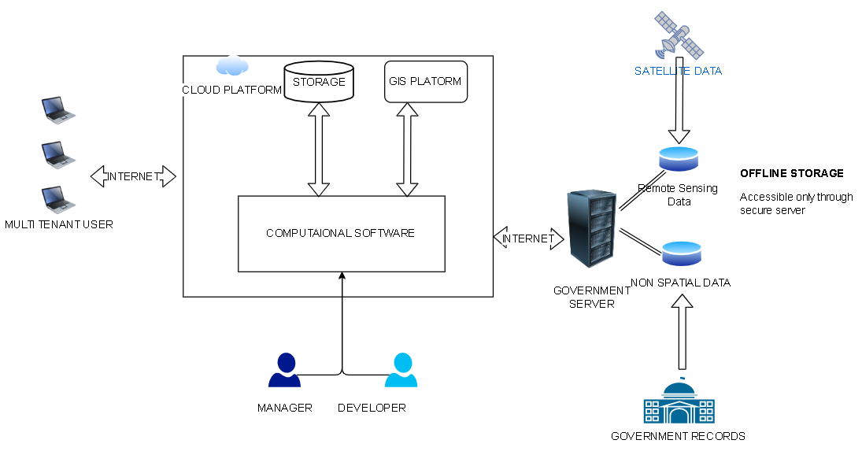

Flow Charts
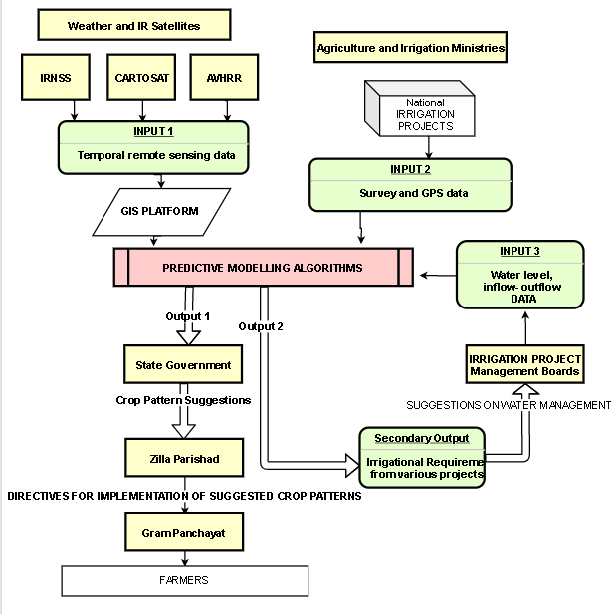

Software Requirements
Since most GIS platforms are cloud based and expensive, ArcGIS, SAGA GIS and GRASS GIS are some of the open source software being considered.
A GIS stores data on geographical features and their characteristics. The features are typically classified as points, lines, or areas, or as raster images. On a map city data could be stored as points, road data could be stored as lines, and boundaries could be stored as areas, while aerial photos or scanned maps could be stored as raster images.
Geographic Information Systems store information using spatial indices that make it possible to identify the features located in any arbitrary region of a map. For example, a GIS can quickly identify and map all of the locations within a specified radius of a point, or all of the streets that run through a territory.
In addition to the above capabilities, Maptitude implements a professional-strength relational database, a feature critical for GIS software. Attribute data may be freely joined to and detached from geographic layers and tables. Relational data manipulation is integrated with robust and powerful geoprocessing for spatial queries, polygon overlay, and other location-based analyzes. This is supported seamlessly so that data are moved easily to and from relational tables and geographic databases.
All of these platforms are compatible with MatLab and Octave.

Conclusion
Remote sensing can be a practical approach to spatially manage crops and their use of water for irrigated lands.Remote sensing provides a way to monitor crop cover
and a way to compensate for crop model uncertainties.Large scale implementation across India, could potentially increase Gross agricultural output and prevent more than 8,200 farmer suicides annually. Could potentially benefit 20.8 crore cultivators across India. Will increase average agricultural output for at least 76.12 million hectares. Will affect the livelihood of 12% of the Indian population. Could increase total agricultural output by 6%. Diverse crop patterns will also reduce price fluctuations in the domestic market. Will increase average annual income of cultivators by 10,000 rupees. Could potentially increase gross agricultural product by 2.08 lakh crores. Complete Utilization of 15lakh crore worth new agricultural projects can be achieved.

References

- Remote Sensing for Crop and Water Management in Irrigated Agriculture - Doug Hunsaker, Kelly Thorp, Andy French, USDA-ARS Arid Land Agricultural Research Centre.
- Agriculture and Food Management-Economic Survey 2018-19 Volume 2
- Remote Sensing in Water Resources Management: The State of the Art -Wim G. M. Bastiaanssen; International Water Management Institute
- Farmer Suicides, ALL INDIA STUDY July 2017;Department of Agriculture, Cooperation & Farmers Welfare, Government of India, New Delhi.
- Mining Surveillance System, Indian Bureau Of Mines,Ministry of Mines, Government of India.

